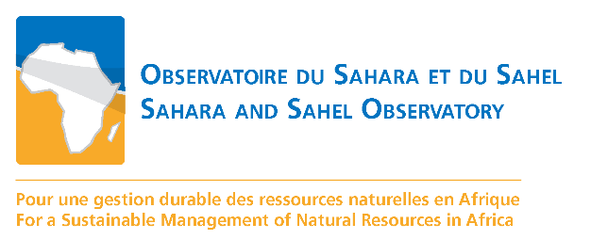

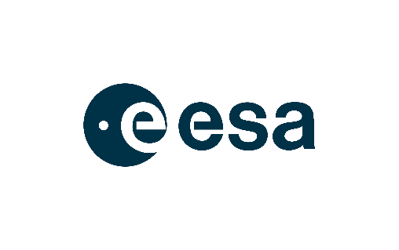

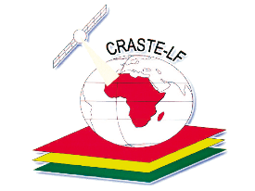

Affiliated to UN

**Global Monitoring for Environment and Security and Africa (GMES & Africa)**

**OSS North Africa Consortium**

**CONCEPT NOTE**

TELE-TRAINING WORKSHOPS

ON THE USE OF EARTH OBSERVATION (EO) FOR SUSTAINABLE LAND AND WATER MANAGEMENT IN NORTH AFRICA



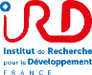~~~~

|  |  |  |  |  |
| --- | --- | --- | --- | --- |
| Workshop | Title | Date | Organized  by | e-learning Tools |
| 1 | EO for seasonal agriculture monitoring | 13-16  October 2020 | CRASTE-LF | LMS crastelf-eacademie  Zoom |

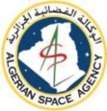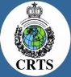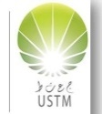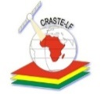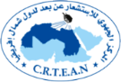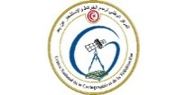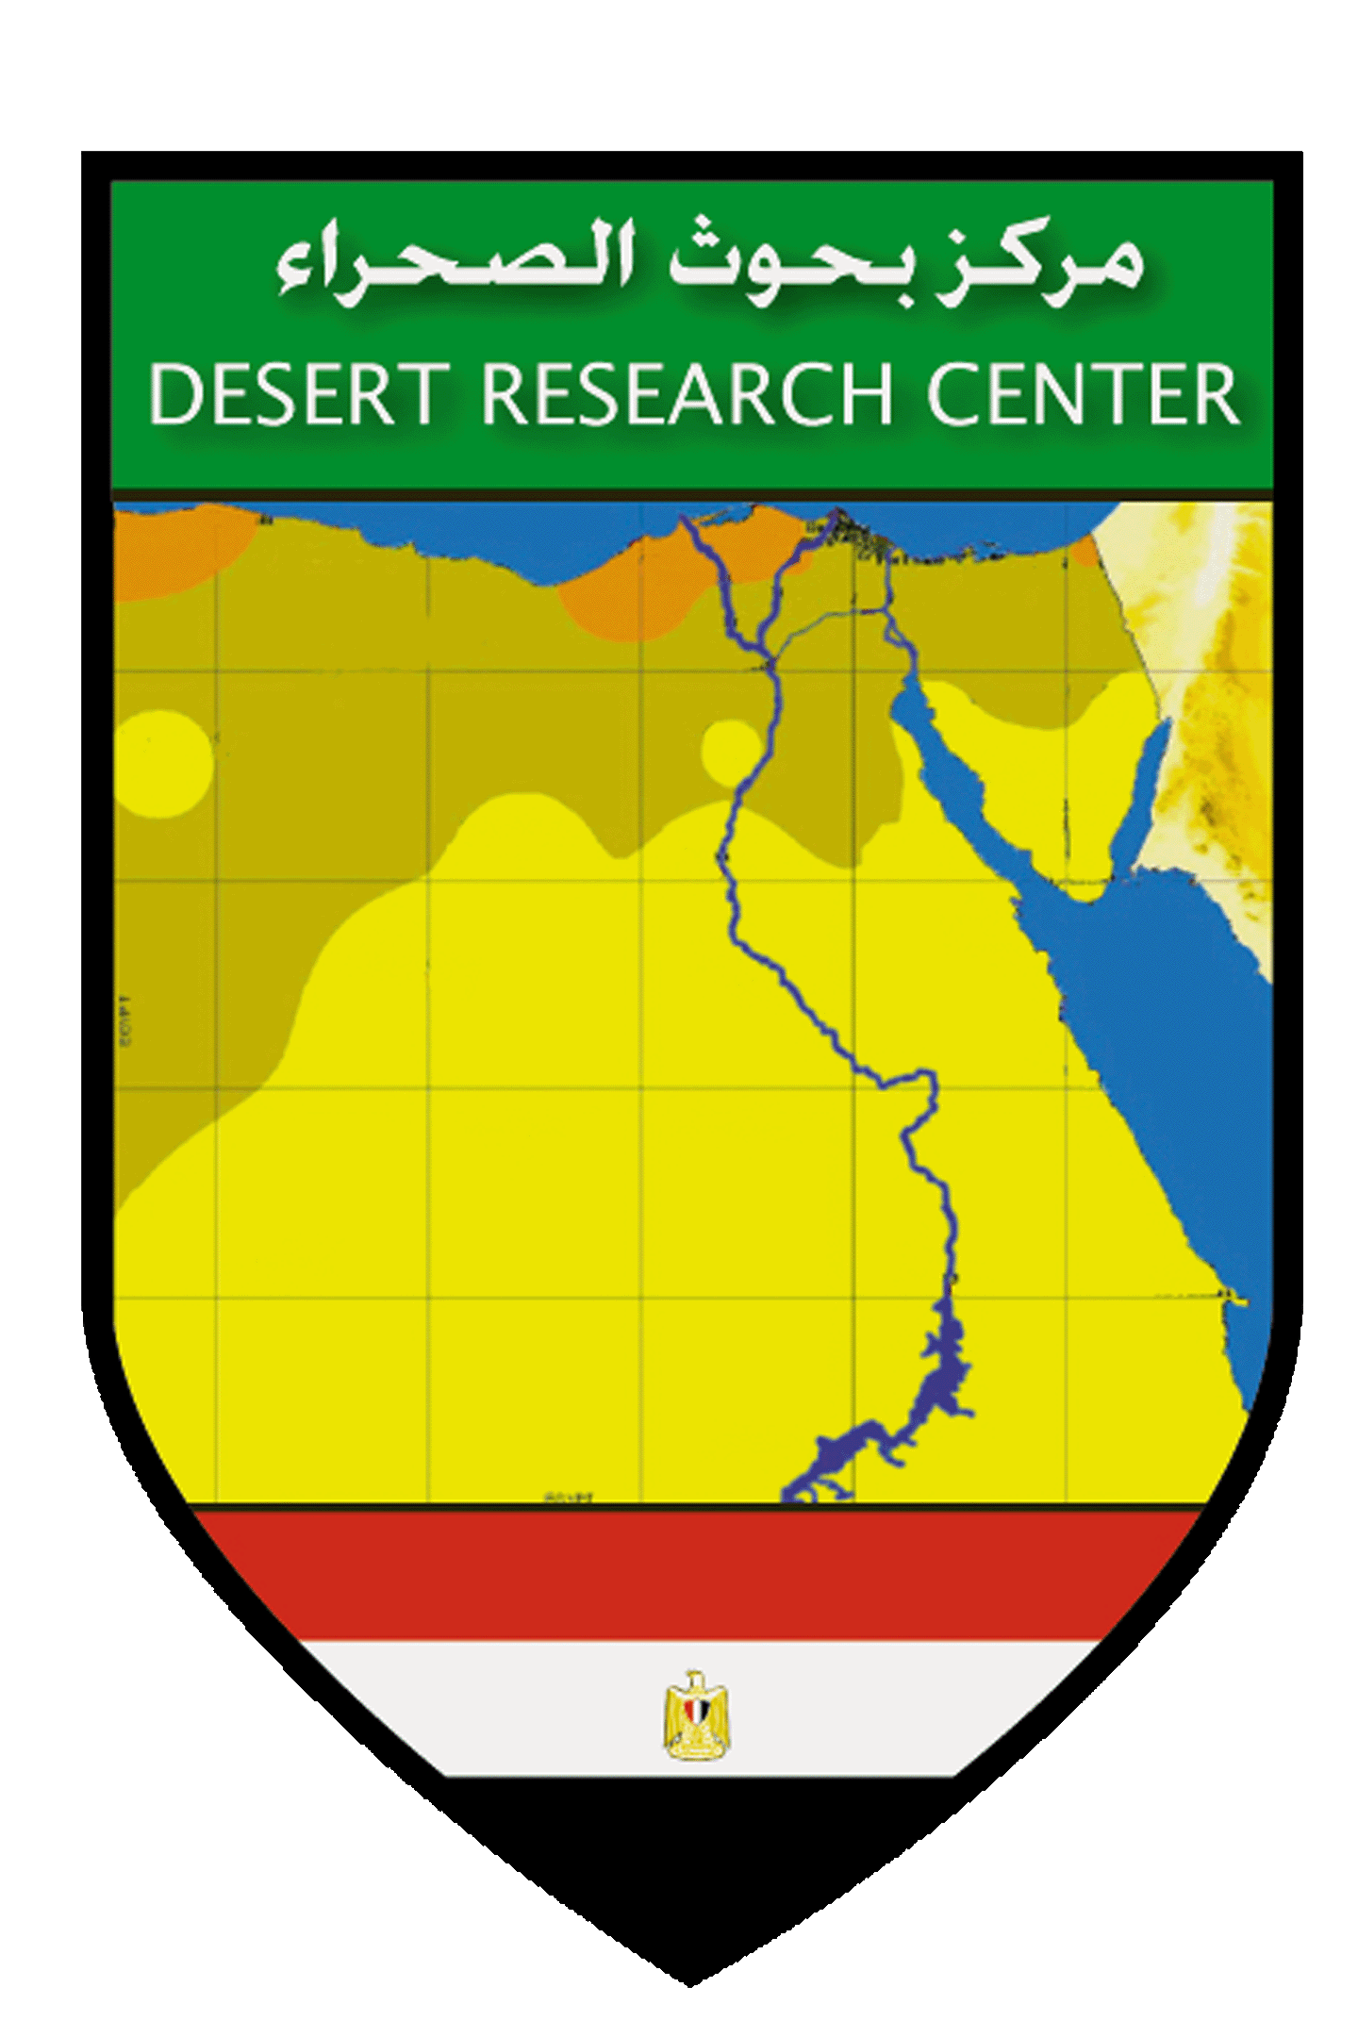

# INTRODUCTION

**GMES & Africa** is a cooperation framework for the development and implementation of Earth Observation-based services that support sustainable development in Africa. The programme focuses on improving the sustainable management of natural, water, marine and coastal resources through the use of Earth Observation (EO) technology. It is being implemented by 72 African institutions organised in 13 regional consortia in charge of conducting various studies relying on the use of EO resources.

**The Sahara and Sahel Observatory (OSS)** is among the consortia of institutions selected by the African Union Commission (AUC) to serve as Regional Implementing Centres for the GMES&Africa Support Programme. OSS is thus coordinating the GMES&Africa OSS-North Africa project entitled **"Earth Observation for Sustainable Land and Water Management in North Africa" (EO-SLWM/NA)**. This project is conducted in partnership with North African key institutions involved in the promotion and development of EO: ASAL, DRC, LCRSSS, CRTS, UNA, and CNCT for the national level, CRTEAN and CRASTE-LF for the regional level[1].

**The GMES & Africa OSS-North Africa project’s** overall objective is to support decision-making in sustainable natural resources management through the provision of products and services based on EO data and techniques. To achieve this objective, three (03) specific purposes have been defined:

* The development and sustaining of decision support services for natural resources managers.
* The boosting of regional cooperation and promotion the capacity exchange on natural resources management in North Africa.
* The capacity building and awareness raising among partners and end-users on the potential and better consideration of technical data and EO applications.

Training is one of the four pillars of GMES&Africa program. GMES and Africa Training Strategy addresses the need to develop critical skills and expertise in EO applications, strengthen space-based and in-situ infrastructural capacities of technical institutions in Africa, develop user-centric EO services, and foster communication to ensure effective use of services and products that maximize EO benefits.

As part of the implementation of the **GMES & Africa OSS-North Africa project**, three operational services are currently in the process of development:

* **Service 1 -** Water Abstraction Surveillance, Monitoring and Assessment in Irrigated Areas.
* **Service 2 -** Land Degradation Monitoring and Assessment.
* **Service 3 -**Agriculture Seasonal Monitoring, Early Warning and Assessment.

Aware of the fundamental role of capacity-building actions for the proper appropriation and efficient use of the products and services, the OSS North Africa Consortium has attached a crucial importance to capacities enhancement and strengthening activities, considering its national partner needs. Therefore, the consortium found it relevant to set up a concrete planning concerning the fulfilling of capacity building activities for its partners, and adapt the trainings to the services themes. Three trainings sessions are planned, one session per service theme.

A training strategy and a work plan were already proposed and adopted for the capacity building activities predefined in 2020 and 2021. In this strategy, three main categories of actors have been selected to be taken into account in the trainings:

* The national task leaders made of EO experts from national mapping and spaces agencies (with the support of EO experts from regional levels).
* The end-users at both national and local levels in the member countries.
* GMES consortia who are interested in one of the three themes are welcome to join this training, which reinforces the cross-fertilization actions that our consortium is undertaking.

Thus, the tele-workshops would take place as follow:

* Training 1: **EO for seasonal agriculture monitoring** on **October 13 - 16, 2020**.
* Training 2: **EO for irrigation monitoring and water uptake estimation** on **November 2020 (dates still to be defined)**.
* Training 3: **EO for land degradation assessment** on **December 2020 (dates still to be defined).**

**This concept note is developed to organize the first tele-training, which will be conducted by the African Regional Centre for Space Science and Technology Education in French Language (CRASTE-LF) affiliated to United Nations2, in collaboration with OSS North Africa Consortium and GMES&AFRICA partners.**

# OBJECTIVES

This first tele-training aims to achieve three (03) main objectives:

* Ensure an effective access and use of Copernicus EO resources for agricultural monitoring needs.
* Strengthen knowledge and enhance operational skills on crops mapping technics using EO-based learning approaches.
* Enable optimal exploitation of the ESA EO products within cloud computing environment.

# TARGETED AUDIENCE

About 35 experts in EO for agriculture from national and regional OSS consortium partners and guest persons from others institutions or consortia.

# DOCUMENTS AND WORKING TOOLS

The tele-training will be held via the CRASTE-LF e-learning management platform (crastelf-eacademie3) and possibly via Zoom video-conference platform. A workshop-kit, comprising a set of documents, working tools and virtual machine access, will be handed over to participants before the start of the workshop. We have foreseen an availability of the Virtual Machine for the participants of two months. The training materials will be available and accessible for free on the GMES&Africa digital E-training platform.

In order to make the training practical and useful each participant is required to use a computer strong enough with a good internet connection.

2 <https://www.youtube.com/watch?v=0PpwNaDG7sk>

# EXPECTED RESULTS

The expected results from the first tele-workshop are as follows:

* Different approaches and methodologies for using EO data and technics in agriculture monitoring are presented.
* Practical and technical aspects of EO based crops mapping are performed by the participants.
* Procedures of EO dataset processing within cloud computing environments for generating automated process of crop mapping are practiced by the participants.

# PROGRAM AND SESSIONS

The first tele-trainings will consist of three (03) main sessions:

* **Session 1 -** Copernicus EO segment for agriculture-Operational use cases.
* **Session 2 -** EO based learning approaches for agricultural areas mapping-Desktop process.
* **Session 3 -** Agricultural areas analysis using cloud computing platforms and virtual machines.

**Please see the agenda bellow.**

# CERTIFICATION

As a regional training center, the CRASTE-LF will certify trainees for their participation to the workshop. A digital certificate will be emailed at the end of the training.

3<http://www.crastelf.org.ma/eacademie/>

# ON LINE EVENT AGENDA

|  |  |
| --- | --- |
| Time | Main activities |
| **Day 1** | |
| 09h – 09h 15 | Crastelf-eacademie connection opens |
| 09h15-09h30 | Introduction Welcome, opening speech and training agenda (OSS & CRASTE-LF teams) |
| 09h30-10h00 | Keynote presentation: Copernicus space segment for crops mapping and monitoring - Operational use. (ESA) |
| 10h00-10h30 | Interactive session |
| 10h30-10h45 | Break |
| 10h45-11h05 | EO data analytics for land use and land cover mapping. (IRD) |
| 11h05-11h35 | Interactive session |
| 11h35-12h15 | Two case-studies for agriculture monitoring using Optical and SAR Copernicus data.  (i) Sentinel 2 coupled to thermic bands for irrigated/no-irrigated areas mapping, (ii) Radar Sentinel 1 imagery for surface moisture estimation. (CESBIO-TETIS) |
| 12h15-13h15 | Interactive session – Sharing good practices |
| 13h15-13h30 | Wrap-up and adjourn |
| **Day 2** | |
| 09h15-09h30 | Crastelf-eacademie connection opens |
| 09h30-09h35 | Welcome & Day 2 program presentation |
| 09h35-11h00 | Hands-on exercises on crop type classification using Sentinel 2 data and open source software and libraries - An image data processing workflow. (IRD) |
| 11h00-11h15 | Break |
| 11h15-13h15 | Hands-on exercises on crop type classification using Sentinel 2 data and open source software & libraries – Ground truthing & Accuracy assessment. (IRD) |
| 16h00-16h30 | Interactive session – Sharing good practices |
| 16h30-16h45 | Wrap-up and adjourn |
| **Day 3** | |
| 09h15-09h30 | Crastelf-eacademie connection opens |
| 09h30-09h35 | Welcome & Day 3 program presentation |
| 09h35-11h00 | Cloud computing introduction. (ESA) |
| 11h00-11h15 | Break |
| 11h15-12h00 | Agriculture monitoring in cloud environment. (ESA) |
| 12h00-13h00 | Jupyter Notebook to derive vegetation indices. (ESA) |
| 13h00-13h15 | Wrap-up and adjourn |
| **Day 4** | |
| 09h15-09h30 | Crastelf-eacademie connection opens |
| 09h30-09h35 | Welcome & Day 4 program presentation |
| 09h35-11h00 | Hands-on exercises on agriculture monitoring in cloud environment I. (ESA) |
| 11h00-11h15 | Break |
| 11h15-13h00 | Hands-on exercises on agriculture monitoring in cloud environment II. (ESA) |
| 13h00-13h15 | Wrap-up and workshop conclusion & cloture |

1. ASAL : Algerian Space Agency ; CNCT : Tunisian National Center of Mapping and Remote Sensing ; LCRSSS : Libyan Centre for Remote Sensing and Space Sciences ; DRC : Egyptian Desert Research Center ; UNA : Mauritanian University of Nouakchott Asriya ; CRASTE- LF : African Regional Centre for Space Science and Technology Education in French Language based in Morocco ; CRTEAN : Regional Center for Remote Sensing of North Africa States.